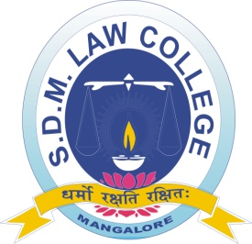
SHRI DHARMASTHALA MANJUNATHESHWARA LAW COLLEGE & CENTRE FOR P. G. STUDIES & RESEARCH IN LAW, MANGALURU
-------------------------------------------------------------------------------------------------------------------------
Application for Add on Certificate Course for the Academic Year 2020-2021

PHOTO***
1. Programme Name: Add on Certificate Course: _______________________
2. Name of the candidate (Block letters): Mr. /Ms. /Mrs. _________________________________________________________________
3. Roll Number: _________
__________________
4. Class: __________________________________
5. Date of Birth:
6. Name of the subject opted-
7. Fee paid**: __________________________________________________________________
8. Mode of Payment: online/offline
8 Mobile Number:
9. Residential Address: __________________________________________________________
______________________________________________________________________________
10. Email Id.: ___________________________________________________________________
I hereby declare that, I have read and understood the conditions of eligibility for the program for which I seek admission. I will abide by all the rules of our College and the rules governing add on courses.
Place:
Date: Signature of the Applicant
( )
NOTE:
* Rs. 1000/- for each subject
** One extra photo of passport size for each subject must be submitted.

OFFICE
- Number of add on courses opted by the student 1
- Amount of Fees paid : In Figures: __________
In Words: __________________________________________________________________
Signature of the cashier
( ) Verified

(Course Co-Ordinator)

