

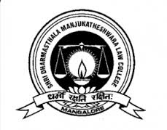

**Shri Dharmasthala Manjunatheshwara Law College & Centre For P.G. Studies & Research In Law**

*In collaboration with*

**United Nations Development Programme(UNDP) And National Law School of India University, Bangaluru**

*Present*

**Two Day Legal Awareness Workshop*on*Biological Diversity Law In India**

**Date: 15th & 16th February 2019**

**Registration Form**

|  |  |
| --- | --- |
| Full Name: Dr/Mr/Ms/Mrs |  |
| Designation |  |
| Institution/Company/Organization/  School/College |  |
| Office Address |  |
| Email: |  |
| Contact Number |  |
| Whether Accommodation is required(On Payment basis) |  |

Duly Filled Registration form shall be mailed to [sdmlawconference2017@gmail.com](mailto:sdmlawconference2017@gmail.com)